**GANPAT UNIVERSITY**

**U. V. PATEL COLLEGE OF ENGINEERING**

**B.Tech CE/IT Semester IV**

**2CEIT404: Python Programming**

**Practical-13:**

Step 1: Create virtual environment

python -m venv first

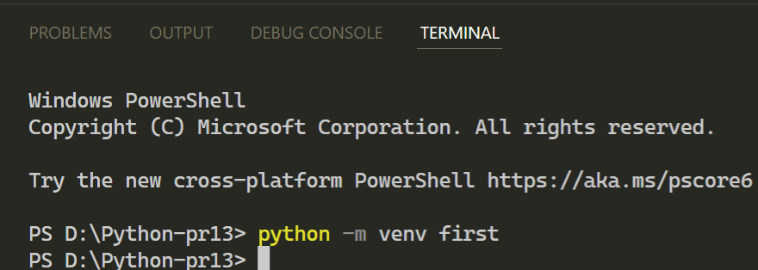

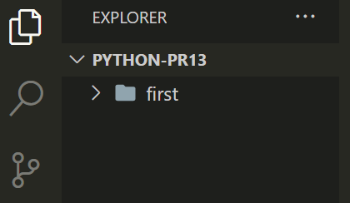

Step 2: Activate virtual environment

source first/Scripts/activate

Step 3: Install Django

pip install django –upgrade

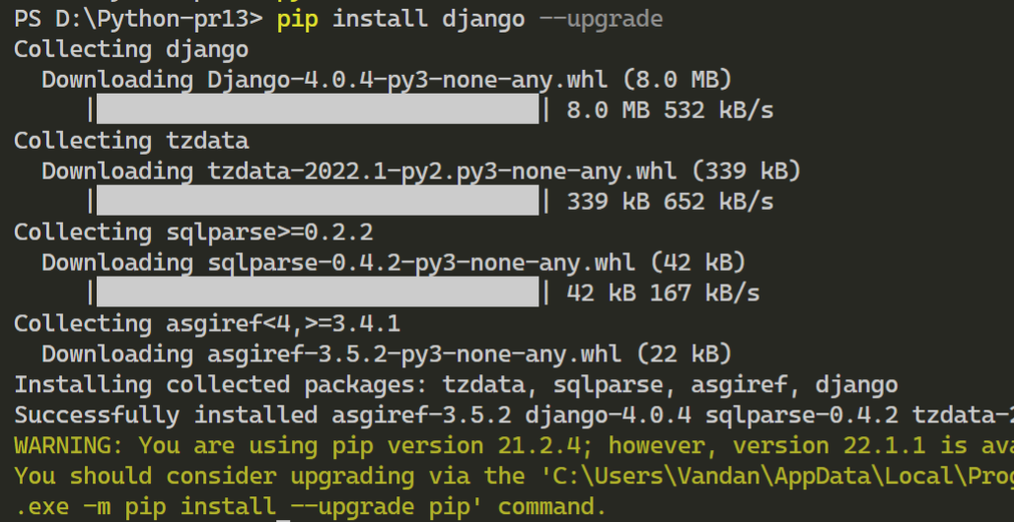

Step 4: Save all installed requirements in requirements.txt file

python -m pip freeze > requirements.txt

Step 5: Create a new project

Django-admin startproject project1

